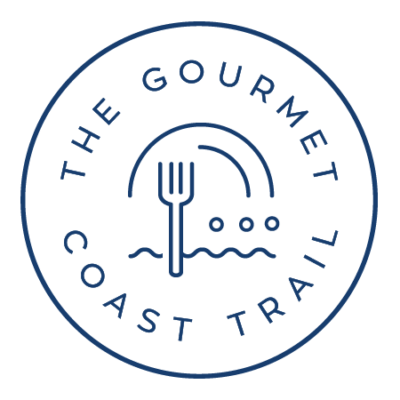
APPLICATION TO ADVERTISE ACCOMMODATION
Visitors to the Gourmet Coast are seeking a memorable stay. They are discerning visitors who value quality experiences and seek out local knowledge. If you offer this to your customers, we’ll make great partners in promoting our beautiful stretch of coast as a unique gourmet destination.
The Gourmet Coast Trail (GCT) Inc is a member-based community association of food-related businesses founded with the objective of building year-round food tourism on the far south coast of NSW.
To this end, the Association has established a website and program of marketing campaigns to promote a food trail covering the geographic coastal area bordered by Batemans Bay to Eden: www.gourmetcoasttrail.com.au
To advertise your accommodation as part of The Gourmet Coast Trail marketing program, please submit the attached application form.

Benefits of Advertising with The Gourmet Coast Trail
- We connect and promote culinary delights across council boundaries to build a critical mass that attracts tourists and encourages them to explore the region
- We reach and attract adventurous, food-loving tourists from Canberra, Sydney and Melbourne by championing the finest gastronomic produce, products and experiences the Far South Coast has to offer
- We maximize your online exposure through both geographic and thematic itineraries and map-based listings with links to your website
- We extend your social media reach through our network of followers and members, partnerships with marketing agencies and paid advertising (In 2022-23 we will spend over $50,000 on SEO and paid digital placement for the Gourmet Coast Trail).
As an advertiser, your business will receive:
- An individual profile page on the Gourmet Coast Trail website with hyperlinks to your business website and social media
- Inclusion on the Gourmet Coast Trail interactive map
- Social media posts about your business to our followers and via our media partners
- Use of visual assets that we create for collective marketing

Eligibility criteria
To advertise your accommodation on the Gourmet Coast Trail website, your business must:
- Provide an accommodation service
- Be located within the geographic area of Batemans Bay – Victoria border – Nimmitabel.
- Provide a service that supports the following Gourmet Coast brand values:
  - People: Welcoming, knowledgeable, intriguing
  - Place: Beautiful, unique, relaxed, uncrowded, open
- Before your accommodation is listed on the website, you will need to:
- Provide the required information
- Provide quality photos for the Gourmet Coast trail website
- Pay the listing fee
- Agree to our terms and conditions

Cost and period of listing
- Period of listing: Financial year (1 July –30 June)
- Year-long listing: Annual fee $440 inc GST
- Pro rata: For first-time listing only, a pro-rata fee of $110 inc GST per quarter for the remainder of the financial year to 30 June
- Renewals: We will send you a renewal notice in April
- Update fees: We will upload one round of new photos each year for free
We will make one round of content changes each year for free
Additional content changes cost $88 per round of editing

How to Apply
If you would like to apply to advertise, please complete the attached form and return to eat@gourmetcoast.com.au or complete the online form at www.gourmetcoasttrail.com.au (find it on the About Us page)

Queries
Email: eat@gourmetcoasttrail.com.au Phone: Fiona 0448 453 422
Application to Advertise Accommodation – Gourmet Coast Trail
Please complete this form and email it with your photographs to eat@gourmetcoasttrail.com.au

Contact Details for Billing (Not for Publication)
Contact Name
Billing email
Billing Phone
Billing postal address
New or Renewing

Business Details for Publication
Business Name
Business physical address
Business website
Business phone
Business public email
Facebook link
Instagram link
Accommodation type | Multiple selection is OK. Delete categories that do not apply  Self-catering / Bed & Breakfast / Hotel / Motel / Farm stay / Pub / Serviced apartment / Private rental / Carvan park / Camping / Glamping / Eco-tourism / Cabins / Villas
Sta rating | If applicable, Official star rating on www.starratings.com.au
Accessible | Yes / No
Pet friendly | Yes / No
Pool | Yes / No
Parking | Yes / No
EV charge point | Yes / No
Free WIFI | Yes / No
Gym | Yes / No
Water View | Delete categories that do not apply  River / Lake / Estuary / Ocean / None
Self Catering | Yes / No
In-house meal options | Yes / No
Other notable facilities
Business tag line | Example: “Your perfect romantic getaway” Please note, we might edit this tag line to give you a point of difference from other accommodations listed on our website
100 words about your business | Please note, we will edit this information to achieve a common tone of voice for the Gourmet Coast Trail brand and to highlight features of your business that will appeal most to our target market.
Business logo attached | Yes / No
Photo 1 credit information | Include credit information only if pre-existing licences require it to be shown.
Photo 2 credit information
Photo 3 credit information
Photo 4 credit information

By submitting this form, I accept the following terms and conditions:
1. I am an authorised representative of the business named on this form
2. The named business will uphold the brand values and collegial spirit of the collective marketing philosophy of the Gourmet Coast Trail Association Inc
3. This application is for the accommodation element of the named business at one location only (the application does not cover multiple properties or locations or any food businesses owned by or associated with the named business, including in-house meal options)
4. The Gourmet Coast Trail Association Inc is permitted to change or edit the supplied content at its discretion
5. The named business will maintain its owned online presence (business website and social media)
6. The named business will notify the Gourmet Coast Trail Association Inc of any changes to its details
7. The named business owns the copyright or unrestricted licence of any images and content it supplies, and grants to the Gourmet Coast Trail an unlimited, unrestricted and royalty-free licence to use the images and content in perpetuity
8. The named business will display the Gourmet Coast Trail logo on its website for the period of advertising
9. The named business will ‘Like’ Gourmet Coast Trail social pages
10. The Gourmet Coast Trail Association Inc may promote the named business in any of its marketing activities, including with third parties
11. The period of advertising ends on 30 June of each year
12. Advertising fees are non-refundable
13. The named business will maintain appropriate insurances, approvals and certification to operate
14. The named business indemnifies the Gourmet Coast Trail Association Inc against any claim made in relation to the information, products and services provided by the named business
15. The named business accepts all responsibility for relationship management with its customers regarding the advertised information, products and services
16. The Gourmet Coast Trail Association Inc may suspend the named business’ advertising on the Gourmet Coast Trail website without compensation if these conditions are breached, membership lapses, the business ceases to operate, or the named business does not uphold acceptable standards of service, hygiene or facilities.
Name of authorised representative
Signature

Date

